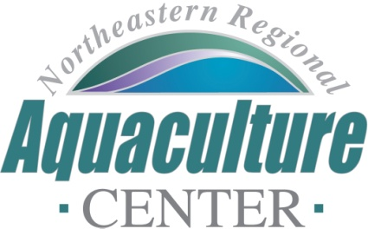
University of Maryland, 2113 Animal Science Building
College Park, Maryland 20742-2317
Telephone: 301-405-6085, FAX: 301-314-9412
e-mail: ssadams@umd.edu

NRAC FULL PROPOSAL REVIEW FORM

Project Code/Title: 23-12: Quantification and communication of ecosystem services of low trophic level farms.
Date Due: December 9, 2022.
- Science, Technology, and/or Extension Program Design (technical merit of all aspects of the project, 30%):

This is an extremely well written proposal based on top quality science and technology and that addresses all three NRAC priorities. The primary outcome of this proposed work is to acquire data and enhance scientific and public understanding of habitat provisioning ecosystem services of shellfish farming. The proposed research will collect quantitative data on the habitat provisioning services on hard clam farms mussel farms and develop a StoryMap for industry and public audiences as a tool for understanding and communication about ecosystem services of low trophic level species farm in the northeast US. Increased awareness of ecosystem services will lead to greater social acceptance, greater willingness to pay, and reduced NIMBY-ism which is a major obstacle to the expansion of coastal nearshore aquaculture. It will therefore also serve to monetarize ecosystem services that can directly benefit farmers across the region, not just those directly involved in the project.

The objectives are clear and the experimental design and analyses are robust (e.g., inclusion of controls, replicated, quantitative, multivariate approaches). There is a real need for these data within the NRAC region.

Excellent 30

- Industry Relevance and Probability of Success (30%):

The development of the StoryMap as a communication tool will mitigate sociological conflicts between aquaculture and other user groups and promote biological and social sustainability, which will likely be most advantageous during the lease permitting process. A greater public awareness of the ecosystem services supported by low trophic level aquaculture will translate into an increased willingness to pay that will translate to profit to farmers across the region. Furthermore, the fact that the StoryMap will be co-designed with local farmers will ensure that the tool provides information that is useful for existing farmers to better market their products to the public by being able to identify and articulate the ecosystem services provided at their farm sites.

Excellent 30
Integration with Extension (20%):

The work identifies key stakeholders and has active participation from industry, albeit at a modest level of replication. The project will address a lack of understanding among the consumers as to the human benefits of nearshore aquaculture beyond provisioning services. This will translate as increased acceptance a reduction in social conflicts among users.

Very Good 18

4. Capacity (10%):

The project centers around a very strong team with diverse skills and clearly defined roles. It incorporates extension and outreach as well as a private company with expertise in translational science. Facilities include UNE’s Center of Excellence and the team has experience working in the field. Industry engagement is reflected among the letters of support. The overall budget is appropriate for the proposed work and the work has a high probability of meeting its goals on time.

Very Good 9

5. Accountability (10%):

While there is no previous NRAC for the PI, this is substantial for co-PIs Munroe (research) and Morse (extension). Previous NRAC funding was also used to leverage funding from USDA-NESARE. The proposal also does an excellent job of highlighting the links between this proposed research and other recent and related projects in the Northeast region. This proposal appears to be an excellent use of NRAC resources with a high likelihood of generating tangible and financial benefits to industry.

Very Good 9

6. Total score: 96

Rating Excellent

Final Recommendation: Must fund

