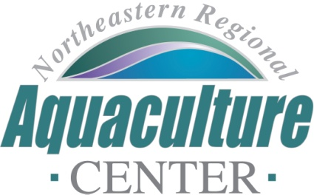
University of Maryland, 2113 Animal Science Building
College Park, Maryland 20742-2317
Telephone: 301-405-6085, FAX: 301-314-9412
e-mail: ssadams@umd.edu

NRAC FULL PROPOSAL REVIEW FORM

Project Code/Title: 23-13: Rebooting the Northeast Aquaculture Extension Network: A skills training and mentorship program for extension professionals.
Date Due: December 9, 2022.
- Science, Technology, and/or Extension Program Design (technical merit of all aspects of the project, 30%):

The goals of this extension proposal are to develop an intensive, training program for extension professionals to foster a viable and equitable aquaculture industry and to develop a mentorship program to strengthen communication and knowledge transfer amongst aquaculture extension agents in the Northeast. The team appears to have used a rigorous approach to identifying the high priorities in terms of trainings to be offered, namely: 1) Engaging Underrepresented Communities; 2) Evaluation - Designing Projects with Evaluation in Mind; and 3) Integrated Multi-Trophic Aquaculture (IMTA) Operations. Momentum for such training has waned as a result of a number of factors (e.g., turnover, pandemic), and the proposed work seeks to revitalize training opportunities for extension agents across the region.

The proposal includes an excellent level of detail as to what will be included in the training sessions; clearly a lot of thought went into this.

Very Good 27

- Industry Relevance and Probability of Success (30%):

Extension plays a critical role in connecting the science and technology with the stakeholders and end users of that information. The proposal makes a compelling case that the strength of extension in the region has been negatively impacted by a number of factors such that the revitalization/resurrection of NAEN is warranted.

Very Good 27

- Integration with Extension (20%): Does this work identify the key stakeholders? Stakeholders include those individuals (industries and agencies) not directly involved in the project. Is? How will the results of this work address the needs of key stakeholders? Will this project extend our

The proposal does a very good job of identifying the stakeholder. The stakeholders for this project will be early career extension agents with < 5 years’ experience in their roles. This will include the students in the training program but also others. The extension plan is appropriately designed to reach these targeted stakeholders, with a complex budget developed to support travel for all parties. The expected outputs, outcomes, and impacts are clearly described.

Very Good 18

4. Capacity (10%):

The project is centered around a team with sufficient experience relative to extension work and the development of training content. The project steering committee will consist of extension professionals, industry members and the project PIs. Training module development teams will be led by one member of the core project team. Mentors will be aquaculture focused extension agents with 5+ years of experience. The proposal includes a very useful table outlining roles, responsibilities and target audiences. Facilities will comprise meeting spaces at partnering institutions and access to top quality AV equipment to create training materials for the training modules. The budget is appropriate for the proposed work and includes rigorous details within the proposal packet.

Very Good 9

5. Accountability (10%):

While the PI appears new to NRAC, Co-PI Mcintosh has a track record of NRAC funding to address barriers to aquaculture, but there is little evidence of leveraging other funding. The proposal also includes information about related training opportunities and how the proposed work compliments and/or differs from those.

Good 8

6. Total score: 87

Rating Very Good

Final Recommendation: Fund if resources are available

