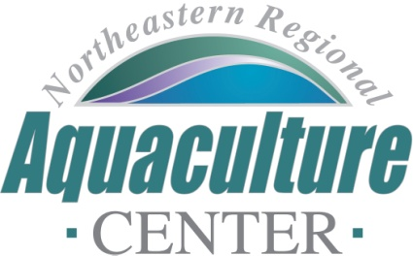
University of Maryland, 2113 Animal Science Building
College Park, Maryland 20742-2317
Telephone: 301-405-6085, FAX: 301-314-9412
e-mail: ssadams@umd.edu

NRAC FULL PROPOSAL REVIEW FORM

Project Code/Title: 23-01: Northern New England Shellfish Best Management Practices.
Date Due: December 9, 2022.
- Science, Technology, and/or Extension Program Design (technical merit of all aspects of the project, 30%):

This proposal was submitted by Christian Brayden from Maine Aquaculture Association, a private, non-profit organization, and the PI intends to do the lions share of the proposed work, drawing on his prior development of BMPs for Maine, and applying these to other states in the region. As such, it seems as though perhaps much of the work already developed for Maine BMPs might be translatable, perhaps reflected in the modest nature of this request. There is arguably little new research to be conducted but rather this project is a series of meetings, conversations and drafting and reviewing of BMPs. While the proposed work does not appear to advance science and technology, it does seek to address significant barriers to sustainable growth and expansion of the industry, primarily centered around user conflicts and permitting issues. The extension plan is adequately described in such a way as to evaluate the success of the effort.

In terms of clarity of presentation of the proposal, it was rather awkward that the PI left the description sections in the proposal in terms of the guidance of what should be included. This was cumbersome to navigate and the formatting was inconsistent across sections, particularly the Current and Pending support section and the letters of support which ran together and many were not on letterhead.

Good 24

- Industry Relevance and Probability of Success (30%):

The intent of the proposal is to address issues that are constraining the sustainable growth of the industry, such as user conflict, long lease wait times and denied applications. While the proposal makes a compelling case that BMPs are needed and barriers exist, estimates of potential growth and economic value are explicitly lacking. The proposal does not propose novel or new technology or new approaches and largely leverages existing information that needs to be drafted and reviewed (reflected by the modest budget request). That said the proposal will create ample opportunity for information to be turned over to the industry for refinement and adoption that may well eventually become self-sustaining. The refinement of information developed for Maine is likely to have applicability across additional states and therefore has good probability of success.

Good 24
3. Integration with Extension (20%):

The PI has met with a significant number of industry members and has identified some of the key stakeholders. Greater involvement of regulatory authorities could have been beneficial, however, when it comes to consideration of the implementation of BMPs and their viability within a regulatory framework. The outreach and information dissemination plan appears robust. The outcomes seem straightforward and the budget is appropriate for the scope of work.

Good 16

4. Capacity (10%):

PI Brayden has met with over 80 farms. Co-PI Belle has developed BMPs for salmon in the early 23002 and has helped to developed shellfish BMPs as well. The project team also includes two extension specialists (Kenter and Morse). While there is not industry representation as part of the team, the proposal includes a strong suite of letters of support from industry as evidence that they have been thoroughly engaged prior to the submission. Requirements for facilities are modest, given the nature of the project and the budget is appropriate in light of that and the scope of the proposed work. The project is likely to meet its time-sensitive goals.

Good 8

5. Accountability (10%):

Only Morse has received previous NRAC funding in the last 5 years, related to sea urchin production. This was a small grant, and it is still too early to determine if value has accrued. The PI seems new to NRAC but has experience in extension and the development of BMPs, which aligns with the proposed work. Across the project team, the experience in extension work is considerable.

Good 8

6. Total score: 80

Rating Good

Final Recommendation: Fund if resources are available

